# Dudu track desktop: how to use it?

First insure you have prepared your data (shape files, and raster files for constraints). For a better understanding of the tools, we provide your we a demo data you can find [here](https://drive.google.com/drive/folders/1YjTu6Q6OI2H59UAIh7Yx7NfSTmA95FzN?usp=drive_link) .

1. Assuming you have downloaded **iPyDisp.exe** and **Data.zip** under the link shared earlier, unzip it in any folder in your local computer, and click on **iPyDisp** icon to launch the app.



1. Configure your simulation as follow:
   1. Set the number of constraints your need for your simulation (2 for our example).

Hit the **set constraints** button when this is done.

The main window will the open as follow.

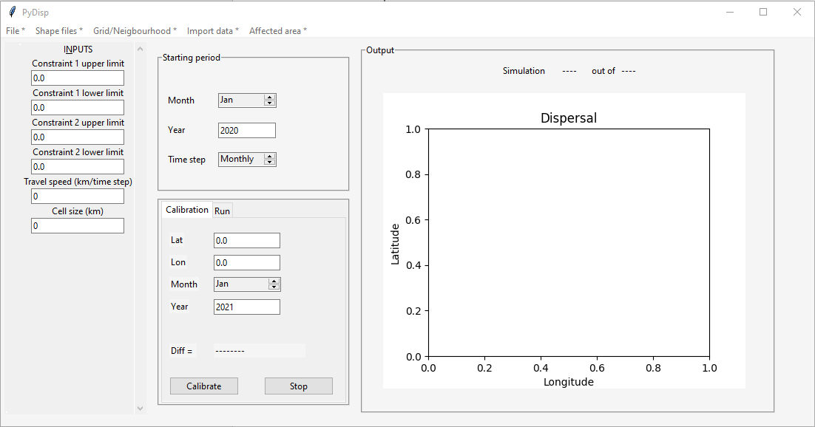

* 1. Load the data folder, via the **File\*** menu in the menu bar, and select the project folder, which should be the folder you extracted earlier (Data.zip)

* 1. Then load the shape files by using the Shapefiles * menu options.

* 1. Next Configure the **Travel speed**, and **cell size** (for our example, **4** on both fields will be ok)

* 1. Next use the options of the **Grid/Neighbourhood** menu to generate the base grid and neighbourhood data.

* 1. Next import the constraints files, using the **Import data menu**. For our example, select ***fruit_crop*** on the first constraint and ***habitat_sui11*** on the second constraint.

* 1. Import the **csv** file of the initial affected area via the **Affected Area \*** menu. For our example we will use ***Release coordinate.csv*** in our Data folder.



* 1. Configure the boundaries (lower and upper) of your constraints as follow:

* 1. Now configure the simulation period and time step, which can either be monthly or yearly. (For our demo we will be using yearly)

* 1. Now we go the run tab below the previous block the configure the amount of time for the simulation and run the model

* 1. Finally, we can **run** our model to get our outputs (the following should be your last result with the demo data)

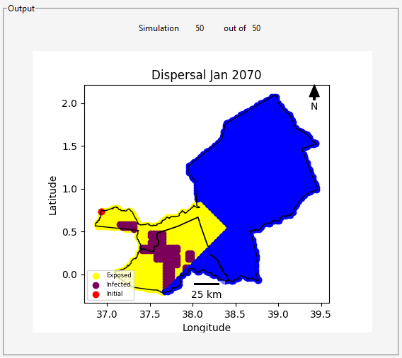

* 1. All the other steps in the simulation are stored in the Data folder automatically in the **Outputs** subdirectory.